Hopfield Network

Joshua Goh
Psych 591 Neural Network Modeling
Project #3
Spring 2007
Introduction
Human beings retrieve complete memories even with noisy cues. These cues are often part of the memories themselves (content-addressed) rather than arbitrary symbolic links (location-addressed). This paper evaluates the Hopfield model (Hopfield, 1982) of how the brain might implement content-addressable memory.
Studies have revealed certain properties of brain memory storage and retrieval. Behaviorally: 1) Repetition of items strengthens their memory (Hintzman & Block, 1971). 2) Content similarity between cue and memory results in false retrieval (Anisfield & Knapp, 1968). 3) Content similarity between memories results in category formation (Murphy, 2002). 4) Retrieval worsens with more items to remember (Strong, 1912). Neurologically: 5) Neuronal organization is highly networked via synaptic connections. 6) Neuronal response is a simple function of inputs from other neurons (Hebb, 2002). The question is how does the brain produce such memory behaviors? Thus we ask: a) how the brain acquires these memories given the apparent simplicity of neural function and architecture, and b) how it retrieves these learned memories.
This paper evaluates the Hopfield model as an account for behavioral findings 1-4, and neural findings 5-7; showing that a network of neurons, with simple response functions, can perform content-addressable memory with the features described above.
Model Operation
The model is a scaled-down version of brain neural architecture, with 16 neuronal units, each connected to the other 15 units but not itself (Fig. 1; finding 5-6). Neurons are simulated as binary threshold units (BTUs: each unit is either active, a=1, or not, a=0), and synapses as a matrix of connection weights (W_{ij}) between units that acquires memories using the following function:
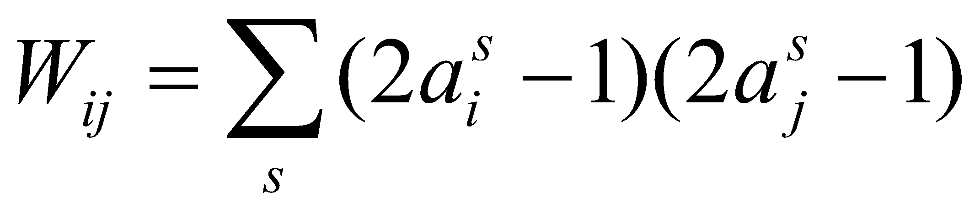
Where a_{i}^{s} is the s^{th} input activation state of the units (realized as vectors of activation values), and a_{j}^{s} is the s^{th} output state. The resultant W_{ij} sums all s training patterns, a, such that any instance of two same-state units increment their connection weight by 1, but two different-state units decrement their weight by -1. Thus, the network remembers by a) updating W_{ij} to additively include new training pattern information and b) storing pattern similarity and dissimilarity as increases and decreases in weights.
Retrieval is realized by introducing a cue test pattern to the trained weight matrix and letting the units achieve a stable state over time according to the following function:
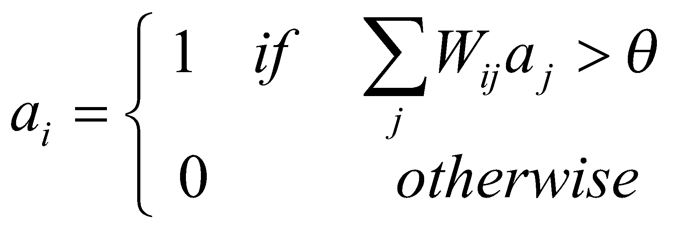
Where θ is the threshold for activation (set at zero), and W_{ij} is the trained matrix. This function is applied iteratively and asynchronously such that only one unit is randomly selected for updating each time (Hopfield, 1982). W_{ij} is now fixed, and acts as a constant force on the units to settle into one of the trained states. With each update, activation states congruent to trained patterns (where the weight, w_{ij}, and the activation, a_{j}, are non-zero and either both positive or both negative) will be maintained (a_{i}=1) while incongruent activation states turned off (a_{i}=0). The network has an instantaneous energy state, E, computed as:
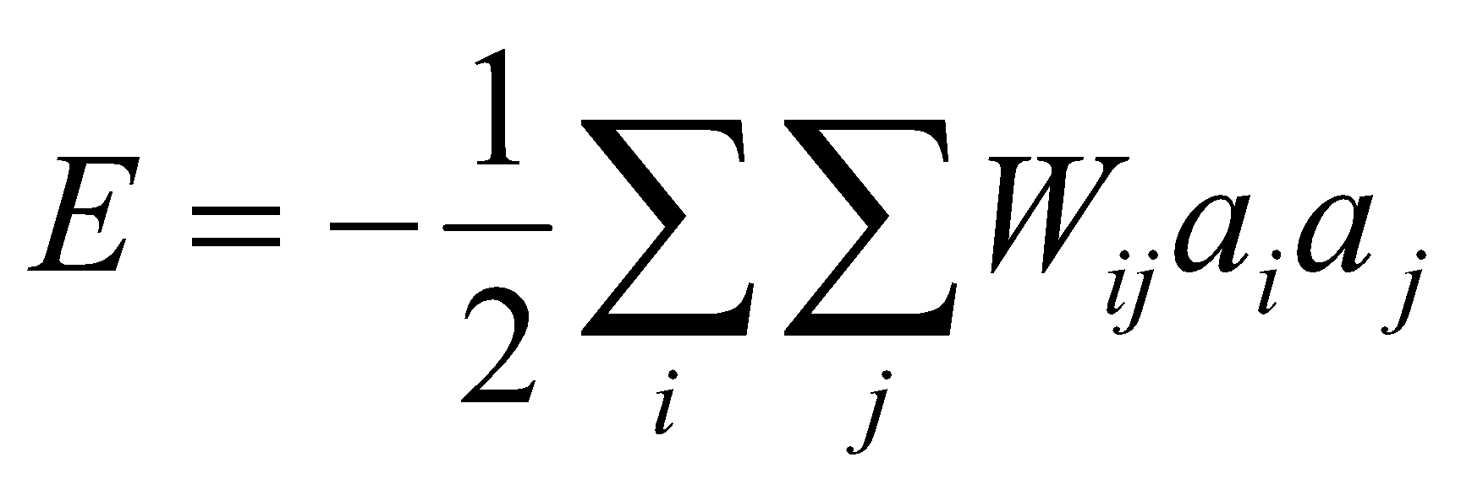
E is largest when all units are active, and either remains the same or decreases as units update to achieve stability (i.e. E is at the lowest value possible given a fixed W_{ij}).
Simulations
All simulations were tested with 20 runs per condition with newly generated test patterns (where relevant) each run. Criterion for stability was 30 consecutive iterations with zero hamming distances (number of units with different values between two instances) between adjacent iterations (minimum settling iteration is 30).
Simulation 1. The network was trained on four orthogonal patterns (Walsh functions: information is unique across these patterns; Fig. 2a-b) and tested with increasingly distorted patterns (Fig. 2c). When tested with the original patterns, the network always settled into the original pattern (Fig. 2d, 2f), with the lowest energy (Fig. 2e). With increasing pattern distortion, the ability of the network to settle in the trained states deteriorated (Fig. 2d-f). Thus, the model has content-addressable memory, retrieving stored content from mildly distorted cues that are part of the content. With larger cue distortions, the model has poorer retrieval (if exact memory is required, retrieving a memory from similar but un-identical cues is false memory; finding 2).
Simulation 2. The network was trained on three different orthogonal patterns but 20 times on the first pattern, 10 times on the second, and once on the third, and tested with each of the three patterns as in simulation 1 (Fig. 3a-b). With more frequently trained patterns, the network settled faster and had smaller hamming distances (Fig. 3c-e). Again, performance deteriorated with greater distortion of test patterns (Fig. 3e). Thus, the network behaves such that repetition is associated with better memory (finding 1).
Simulation 3. The network was initially trained on three random patterns (Fig. 4a) and tested as in simulation 1. Again, greater distortion led to poorer performance (Fig. 4b). Performance also seemed worse than in simulation, possibly due to non- orthogonality in the training patterns (see below). The network was then additionally trained on four random patterns one at a time (Fig. 4c), and tested. Increasing number of trained patterns was associated with longer settling times and hamming distances (Fig. 4d). Thus, with more items to remember, retrieval worsens (finding 4).
Simulation 4. The network was trained on patterns that were distorted from a base pattern, but not the base pattern itself (Fig. 5), and then tested on the base pattern. On average, the network required 42.1 iterations to settle with 1 hamming distance between final states and base pattern, similar to a network trained and tested on the original patterns (compare with simulation 1, zero distortion). Thus, the network acquired the untrained base pattern, forming categories and prototypes from exemplars (finding 3) that were similar enough so the network learned one memory (formed one deep energy well) instead of many different memories (forming six smaller energy wells).
Discussion
The simulations show that the Hopfield network behaves consistently with human memory behavior (finding 1-4), using neuronal function and architecture similar to the brain (finding 5-6) to perform content-addressable memory. The model acquires memory using the learning principle detailed in the model operation, which changes network connections to reflect the history of all the instances of similarity it has received. The network retrieves memory using the activation principle detailed in the model operation, applying the learned connections onto the cue state and forcing the units to adopt one of the original states like a filter. The simulations show the benefit and limits of such a memory system that are similar to human memory performance.
Some caveats should be addressed. Hopfield suggested asynchronous unit updating for computational reasons, and claims that this is more biologically plausible. However, no evidence is offered. Further simulation with asynchronous updating of more than one unit at a time (even more plausible in this author’s opinion) might reveal more about how retrieval is affected. Also, during retrieval, the weight matrix is fixed while the unit states change. This is unlike true neural function in which the memory is constantly updated even during retrieval. A simulation which allows weights to change during testing might answer this issue. Lastly, while categorization and prototype formation are behaviors exhibited in human memory, similar items still remain distinguishable. However, the model loses individual memories when prototypes form. An additional retrieval function might be implemented that is not based on finding cue and memory similarities but rather differences. Thus, if the final state and the original state are not exactly the same, then mark the cue as unlearned even if the Hopfield network thinks it is similar. This might be reckoned with adjusting recognition criteria thresholds in behavioral tests, which is typically thought of as a separate and antagonistic process from signal detection (matching a target memory based on the presence or absence of a stimulus).
Understanding the intricacies of these models might provide us with a clearer mirror of the benefits and pitfalls of the way we remember things. It is also tempting to then speculate how our minds are filters for objective information that may in fact be completely different from what we perceive.
REFERENCES
Anisfield, M., & Knapp, M. (1968). Association, synonymity, and directionality in false recognition. Journal of Experimental Psychology, 77, 171-179.
Hebb, D. O. (2002). The organization of behavior: A neuropsychological theory. Lawrence Erlbaum Associates.
Hintzman, D. L., & Block, R. A. (1971). Repetition memory: Evidence for a multiple-trace hypothesis. Journal of Experimental Psychology, 88, 297-306.
Hopfield, J. J. (1982). Neural networks and physical systems with emergent collective computational abilities. Proceedings of the National Academy of Sciences USA, 79, 2554-2558.
Murphy, G. L. (2002). The big book of concepts. MIT Press.
Strong, E. K. (1912). The effect of length of series upon recognition memory. Psychological Review, 19(6), 447-462.
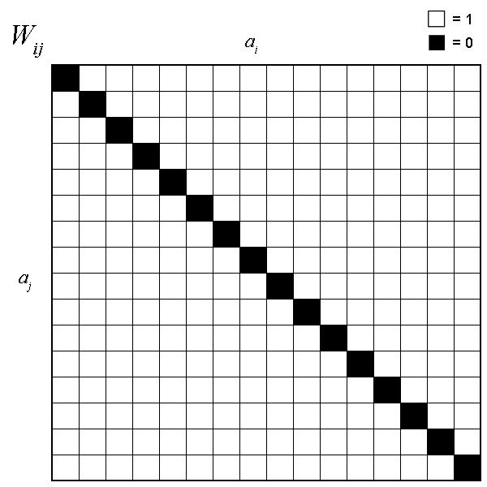
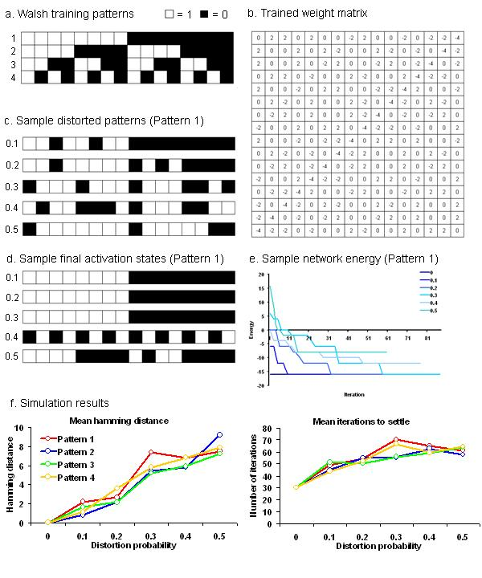
Fig. 1. Weight matrix simulating connections between each of 16 units with all other units except itself.

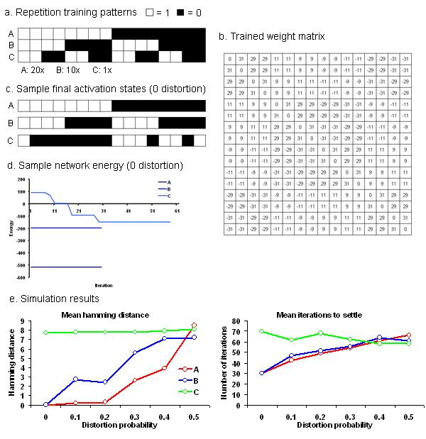
Fig. 2. Simulation 1: Walsh patterns. c) Sample distorted test pattern which is one case (out of 20 runs) of training pattern 1 with changes in activation states in increasing distortion probabilities (rows: 0, .1, .2, .3, .4, .5). d) Sample final activation state after testing the trained network on distorted versions of test pattern 1. The network retrieves pattern 1 with 0, .1, .2, and .3 distortions, but fails with larger distortions. e) Sample instantaneous energy for each iteration for test runs of pattern 1across levels of distortion. With increasing distortion, the network took longer to reach the lowest energy and never reaches the lowest energy state when it settles in the .4 and .5 conditions. f) Mean (average of 20 runs) hamming distance between final states and original patterns, and mean number of iterations to settle for each condition (distortion probability by pattern). With increasing distortion, network performance deteriorates with increasing hamming and number of iterations to settle.

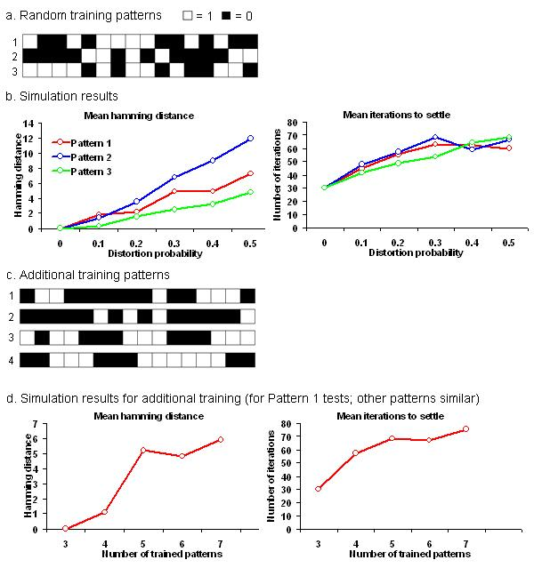
Fig. 3. Simulation 2: Repeated patterns. b) Weight matrix trained 20x on pattern A, 10x on pattern B, and 1x on pattern C. d) Sample instantaneous energy for each iteration for a test run of patterns A, B, and C with no distortion. With more frequently trained patterns A and B, the network reaches the lowest energy state immediately compared to C. e) Mean (average of 20 runs) hamming distance between final states and original patterns, and mean number of iterations to settle for each condition (distortion probability by pattern). With more frequently trained patterns A and B and no distortion, the network retrieves perfectly with zero hamming distance and 30 iterations to settle compared to C. With increasing distortion, the network behaves as in simulation 1.

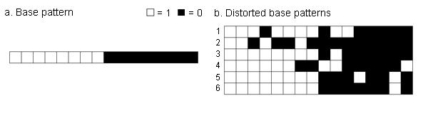
Fig. 4. Simulation 3: Random patterns. b) Mean (average of 20 runs) hamming distance between final states and original patterns, and mean number of iterations to settle for each condition (distortion probability by pattern). With increasing distortion, network retrieval deteriorates as in simulation 1. c) Additional random training patterns included one at a time. d) Sample mean result after testing the network on pattern 1 with no distortion. With increasing number of trained patterns, network retrieval deteriorates with increasing hamming distance and number of iterations to settle.

Fig. 5. Simulation 4: Base patterns. b) Test patterns distorted from the base pattern with a unit change probability of 0.125.

